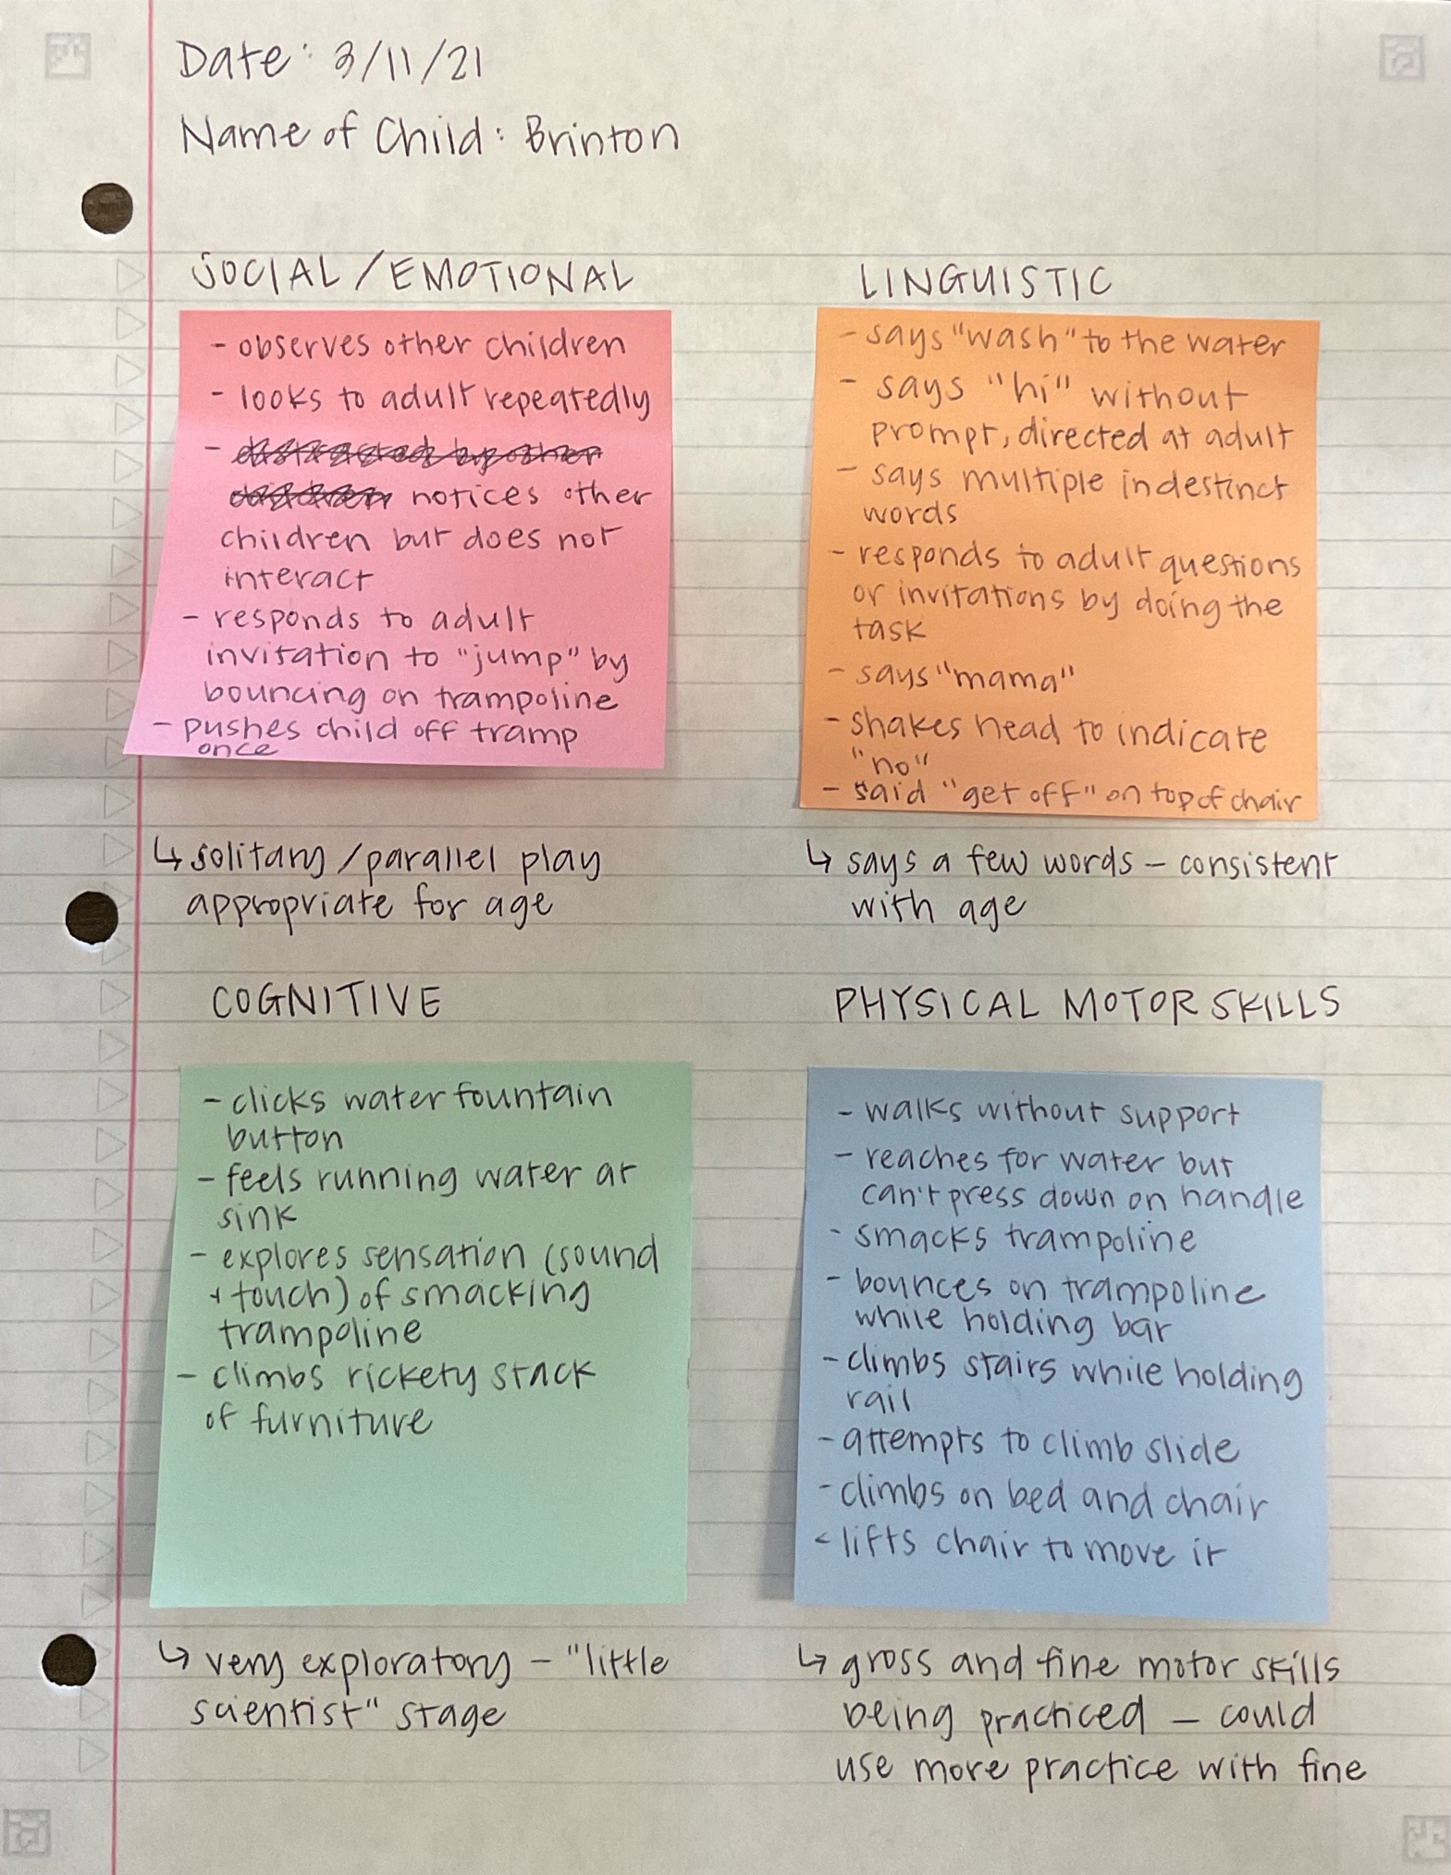
Anecdotal Record

Running Record
Alex is playing with cars. He asks, “Where’s the man?” The adult replies, “Um, you know Alex I don’t know. Oh, Josh has two of them.” Then, addressing Josh, she says, “Josh, can Alex have one of those people?” Josh quietly replies, “No.” The adult looks back at Alex and says, “When he’s done probably” to which Alex replies with a pout, “But I want one!” The adult gently puts her arm around Alex and leans toward him. She asks, “Well how can you get one? Let’s think.” At this point, another child tries to get the adult’s attention to which she replies, “Angela, I’ll help you in one second okay? Let me help Alex with this.” Then, she turns back to Alex and asks, “What can we say?” While the adult gently rubs Alex’s shoulder, Alex turns to Josh and says, “Josh, I want one.” The adult calls Josh’s attention and says, “Josh, Alex wants to tell you something.” Josh walks over. The adult points at the truck Alex was playing with and says, “Look, Josh, his fire truck is missing a guy.” After a couple seconds of silence, she says, “If you’re not ready for Alex’s turn, what can you say to Alex?” Josh looks at Alex and says, “I’m not done yet.” The adult responds, “And what else can you say? You can say ‘you can use it when I’m done.’” As she’s saying this, Alex is saying, “I want one.” Josh repeats, “You can use it when I’m done” and walks away. Alex pouts again, “But I want one now!” Still with her arm around Alex’s shoulder, the adult responds to him, “I know that you want one now, but right now Josh needs two for his play. But when he’s done he’ll give you one.” Alex interrupts, starting to cry, “No, I want one now, I want one now…” The adult rubs his shoulder and responds, “I hear you, I hear that you want one now. We have to wait, can I find you a different person?” Alex continues to cry. She repeats, “I hear you Alex, can we find another person?” Alex cries, “I don’t wanna…” The adult repeats his words, “You don’t want another person?” As Alex continues to cry, the adult explains, “We have to wait until Josh is finished. Right now for his play he needs two.” Alex repeats, “I don’t wanna…” The adult replies, “I know it’s hard to wait. But you will get a turn, Josh knows. Remember his words? He said he’d give it when he was done.” Alex rubs his eyes and keeps crying. The adult continues, “We’ve got to wait til he’s finished.” As Alex is crying, the adult turns her attention back to Angela, “Angela, just a minute, Alex is upset. Alex is upset. He needs my help right now. I’ll go back to helping you with your puzzle very soon. I want to help Alex figure out how he feels.” Alex wipes his face again and the crying continues as the adult turns her attention back to him. She says, “Alex, can I hug you? Will that help you? Can I hold you for a little bit?” Alex mumbles, “No, I just wanna…” The adult leans toward him and says, “You just want the person now. We have to wait.” Alex cries, “I don’t wanna wait.” The adult replies, “Do you wanna go over and talk with Josh about when you can have a turn?” Alex responds, “I don’t want to…” The adult says, “You don’t want to?” Alex: “No…” Adult: “No? I can help you talk with Josh. Do you want me to help you talk with Josh?” Alex’s crying dies down and he replies, “Yeah…” The adult starts getting up as she says, “Okay, let’s go” and then turns to Angela and says, “Angela, we’ll be right back, ok?” The adult gets up and then leans down to Alex and says, “Come on. We have to have a clam word so he can understand us.” She helps Alex to his feet and continues, “Okay, let’s go talk with Josh about why you need one.” The adult picks up the truck and leads Alex by the hand to over where Josh is playing. Josh stands playing with his toys. The adult squats down to the children’s level and says, “So Alex, what do you want to say to Josh?” Alex has stopped crying and clearly tells Josh, “Um, I wanted the people ‘cause…” Josh interrupts, “I’m not done yet.” The adult replies, “Okay but listen to why he needs one.” She looks to Alex, “Can you tell him why you need one?” Alex repeats, “I want one ‘cause…” to which she responds, “Okay why do you need one for this toy? Can you show Josh?” Alex stands fiddling with his hands by his sides and mumbles, “Um… uh… I want… um… um… I need a… like a… like a Max G.” The adult repeats, “Oh you want to do it how Max G was playing with it this morning?” Alex replies, “Yeah.” The adult then turns back to Josh and says, “Okay. So Josh, I’m gonna—let me help Alex out a little bit.” Josh interrupts, “I’m not done yet.” The adult replies, “I know you’re not done, but look Josh.” She points at the fire truck. “One of those guys fits right here, and Alex feels like he needs the rest of the toy. So do you wanna play together with Alex? Maybe we can set up so that you guys can drive away together. Do you wanna do that?” Josh replies, “No…” The adult then turns back to Alex and says, “Let’s go find another person. Let’s see if we can find someone else to fit. Come on.” The adult stands and says, “Come on, Alex, let’s see what we can do while we wait.” She takes Alex’s hand and leads him away as he says, “But I don’t want to…” The adult replies, “I know. But Josh isn’t ready. He’s working on something and I don’t wanna interrupt.” Alex resumes crying as they’ve approached a shelf of toys. As Alex continues crying, the adult leans down and takes a toy off the shelf and says, “Do you think this person will fit? Will he fit in there?” Alex cries, “No!” The adult takes the toy and the fire truck and says, “No, okay… Look, he’s got a little hole.” Alex protests, “No.” The adult takes another toy and says, “Let’s see. How about this girl? Do you think she’ll fit?” Alex continues crying, “No, no…” The adult picks another toy and says, “Okay… how ‘bout this girl?” Alex mumbles something through tears and keeps saying “no.” Alex gets out, “I want something like the fireman.” The adult searches the toys and says, “I don’t think I have anymore firemen… oh, look! Here’s a Lego fireman. He’s got a white fire hat!” She holds up the Lego and asks, “Do you think he’ll fit? Should we go try it?” Alex responds with another “no.” The adult shows Alex how the toy moves, “Look he sits!” Alex, with tears on his face, starts, “But this doesn’t…” The adult asks again, “Do you wanna go try it? I can help you try it” but Alex interrupts, “No, no…” to which she responds, “You don’t want to try…” as she wipes tears from Alex’s face. Alex continues, “it doesn’t go…” The adult nods her head and asks, “Do you wanna take a break from the fire engine and play with the trash truck while you wait for Josh?” Alex sighs, “Yeah…” The adult says, “Okay let’s do that.” She turns to the toys she’s holding and says, “Put that guy there.” They put the toys back in the bin and set it on the shelf. “Okay, I’ll make sure that Josh gives you a turn. You’re gonna do this now? You wanna play trash truck?” She grabs the trash truck toy from the shelf and takes it down for Alex. “There you go!” Alex wipes at his face and mutters something, to which the adult replies, “Oh, let’s grab you a tissue.” She gets up to find the tissues and comes across Josh. She addresses him, “So, Josh, when you’re finished, can you please..” Josh interrupts, “I’m not Josh! I’m Huka Pele.” The adult responds, “Oh! Huka Pele, whenever you’re finished with those firemen, will you give one to Alex?” Josh nods. She continues, “Thank you. When you’re finished, Alex is waiting.” She gets up and walks away.
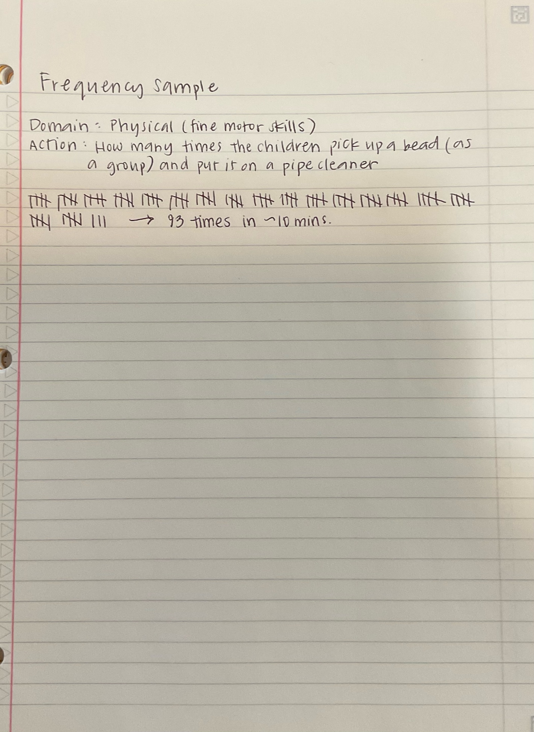
Frequency Sample

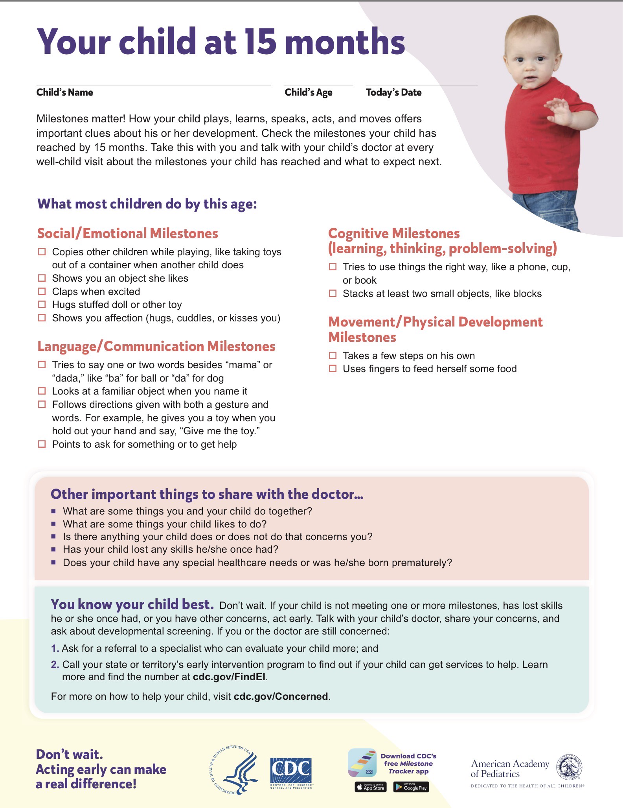
Developmental Checklist

